NOVAC Technology Solutions



Business Requirement Document

For

SGI Philippines – Motor & Non-Motor Products

Revision History

Version No. | Date | Reason For Changes | Author | Reviewer | Approver
Draft 133.1 | 21-Oct-2024 | Auto default the credit period due date. INC ID : 55113 | Arunkumar M | Nijanthan | Mr. Manoj Joseph
133.0 | 22-Oct-2024 | Baseline document for draft version 133.1 | Arunkumar M | Nijanthan | Mr. Manoj Joseph

Table of Contents
1. Introduction 4
1.1. Purpose 4
1.2. References 4
2. Functional Overview 4
2.1. Assumption and Dependencies 5
3. Interface Requirements 5
3.1. Internal Interfaces 5
3.1.1. Hardware Interface 5
3.1.2. Software Interface 5
3.1.3. Communication Interface 5
3.2. External Interfaces 5
3.2.1. Hardware Interface 5
3.2.2. Software Interface 5
3.2.3. Communication Interface 5
3.3. Operating Environment Requirement 5
3.3.1. Hardware Requirements 5
3.3.2. Software Requirements 5
3.3.3. Network Requirements 5
3.3.4. Operational scenarios 6
3.4. Non Functional Requirements (NFR) 6
3.4.1. Reliability 6
3.4.2. Performance 6
3.4.3. Security 6
3.4.4. Usability 6
3.4.5. Other Requirements 6
3.5. Open Issues 6
3.6. Acceptance Criteria 6
4. Appendix A 6

Introduction

Purpose
The purpose of this requirement is to Auto default the “Credit period due date” based on the policy start date and payment terms captured against the proposal. This is applicable for all products.
  - Guidelines, circulars, instructions and directions released from time to time by Philippines Insurance council.

Project scope
To default the Credit period due date” based on the policy start date and payment terms captured against the proposal.

References

Functional Overview
Current Functionality: In the existing system, the user is required to manually enter the PPW (Premium Payment Warranty) due date.
Change in Requirement: The system should automatically populate the credit period count as “1” and the PPW due date based on the “policy start date” and the number of days entered in the “payment terms” field. The auto-calculated date must remain editable, allowing users to make changes if necessary. Apart from this requirement, the existing functionality should remain the same.
Example
Policy start Date (A) | PPW/Payment terms(B) | PPW Date (C=A+B)
21-10-2024 | 80 | 09-01-2025

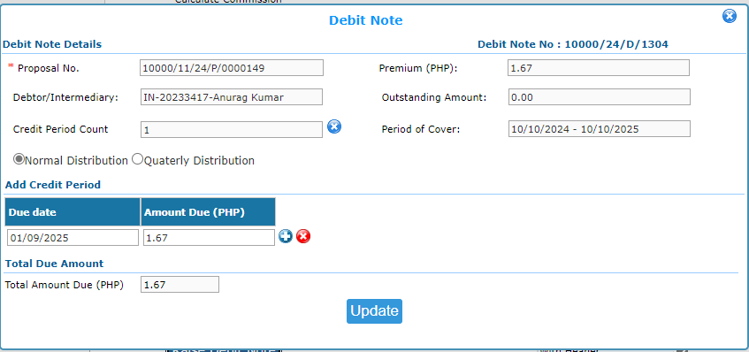
Example for the Auto population of due date

Assumption and Dependencies
<Not Applicable>

Interface Requirements

Internal Interfaces

Hardware Interface
<Not Applicable>

Software Interface
<Not Applicable>

Communication Interface
<Not Applicable>

External Interfaces

Hardware Interface
<Not Applicable>

Software Interface
<Not Applicable>

Communication Interface
<Not Applicable>

Operating Environment Requirement
<Not Applicable>

Hardware Requirements
<Not Applicable>

Software Requirements
<Not Applicable>

Network Requirements
<Not Applicable>

Operational scenarios
<Not Applicable>

Non Functional Requirements (NFR)

Reliability
<Not Applicable>

Performance
<Not Applicable>

Security
<Not Applicable>

Usability
<Not Applicable>

Other Requirements
<Not Applicable>

Open Issues
<Not Applicable>

Acceptance Criteria
- Functional testing will be executed by internal testing team, and the same will be delivered to client for UAT.

Appendix A
Not Applicable

